**Cyber Security Essentials**

**Assignment**

**Day 4**

**Question 1**

**Find out the mail servers of the following domain:**

1. **Ibm.com**
2. **Wipro.com**

**Answer:**

**Step 1**: Open Command Prompt (CMD)

**Step 2**: Type: **nslookup**

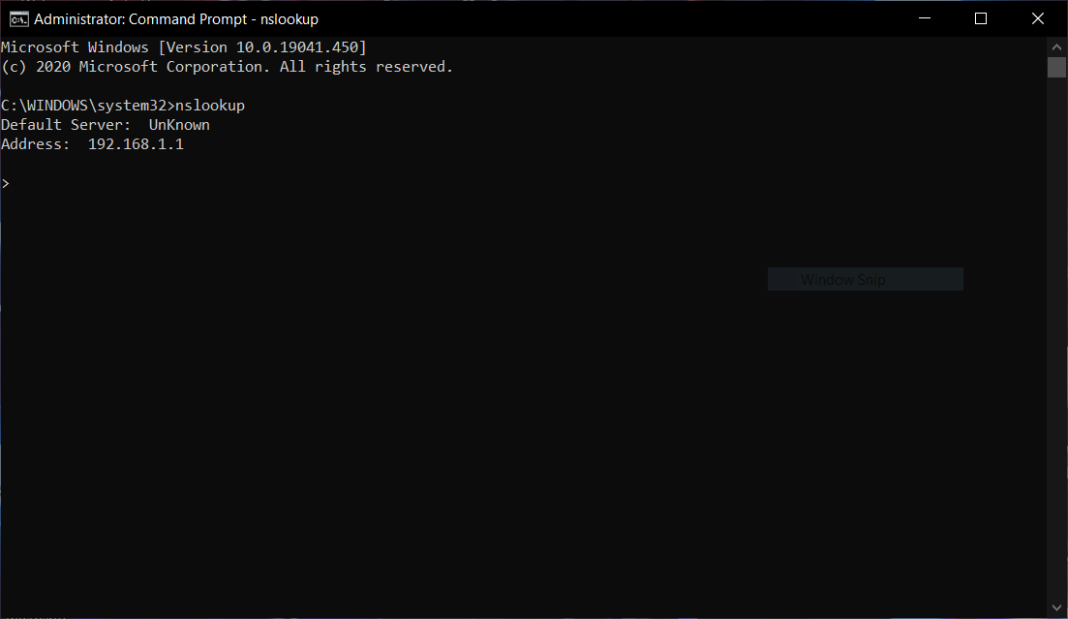

**Step 3**: Type **set type=mx**

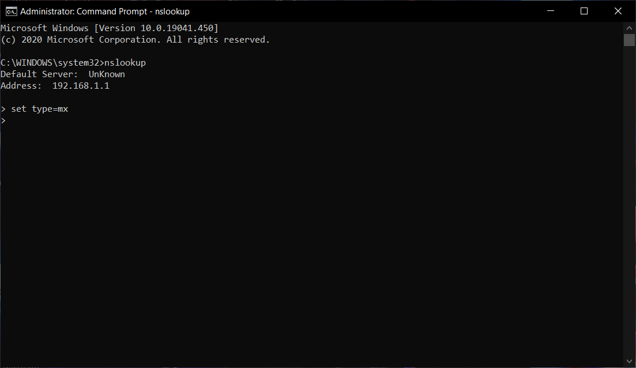

Step 4: Type **ibm.com**

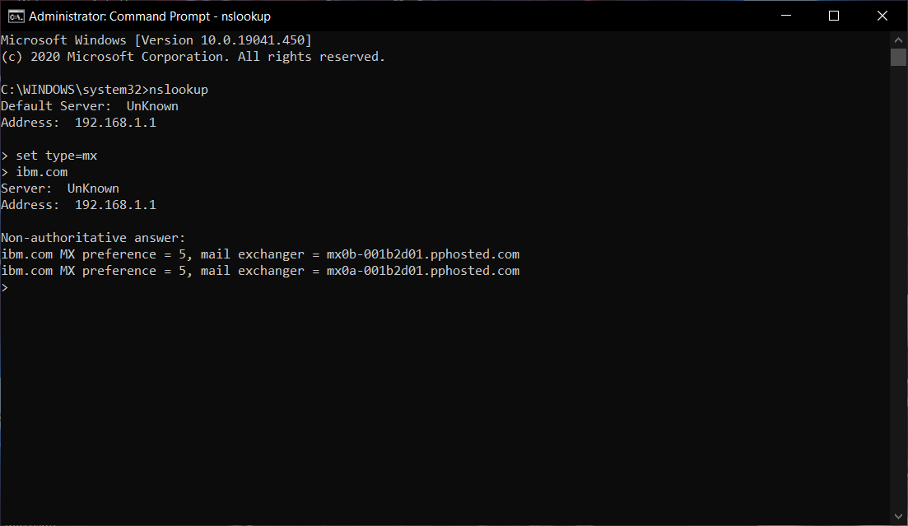

**Mail Servers of ibm.com are:**

1. **Mx0b-001b2d01.pphosted.com**
2. **Mx0a-001b2d01.pphosted.com**

**Step 5**: Type **wipro.com**

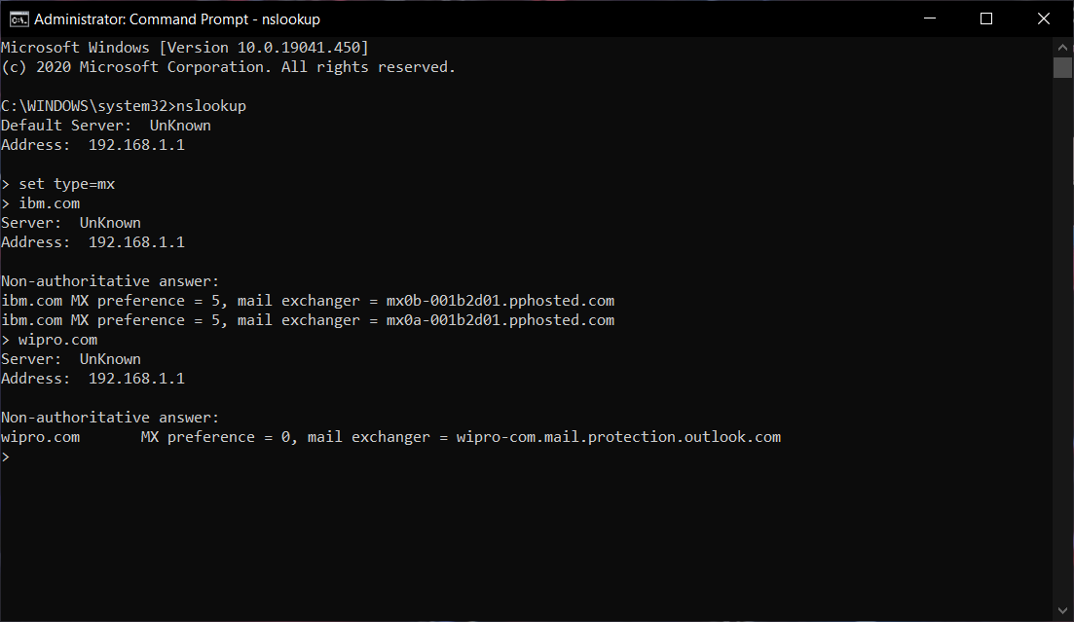

**Mail server of wipro.com is :**

1. **Wipro-com.mail.protection.outlook.com**

**Question 2:**

**Find locations, where these email servers are hosted**

**Answer:** There are two methods to know the IP’s of a mail server they are:

1. By using Command prompt
2. By using online tools

Ex: <https://www.dnswatch.info/>

**I am using 2nd Method to get to the ip’s of the mail server**

**IP’s of mail servers:**

1. Mx0b-001b2d01.pphosted.com

**IP : 148.163.158.5**

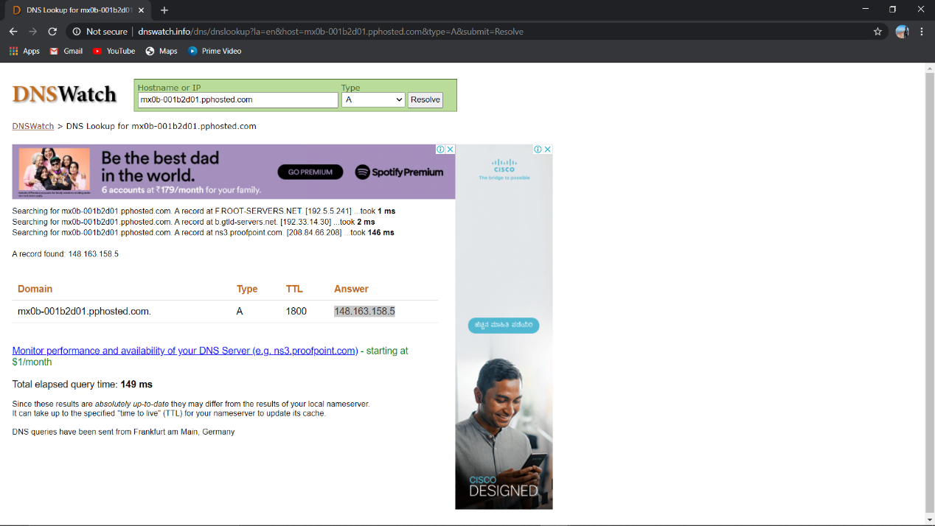

1. Mx0a-001b2d01.pphosted.com

**IP : 148.163.156.1**

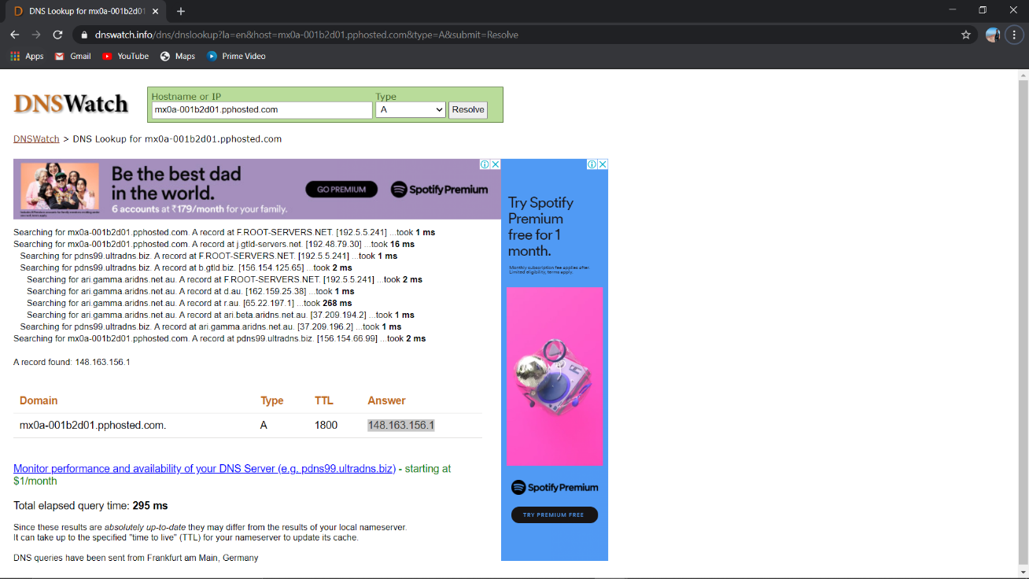

1. Wipro-com.mail.protection.outlook.com

**IP : 104.47.125.36**

**104.47.126.36**

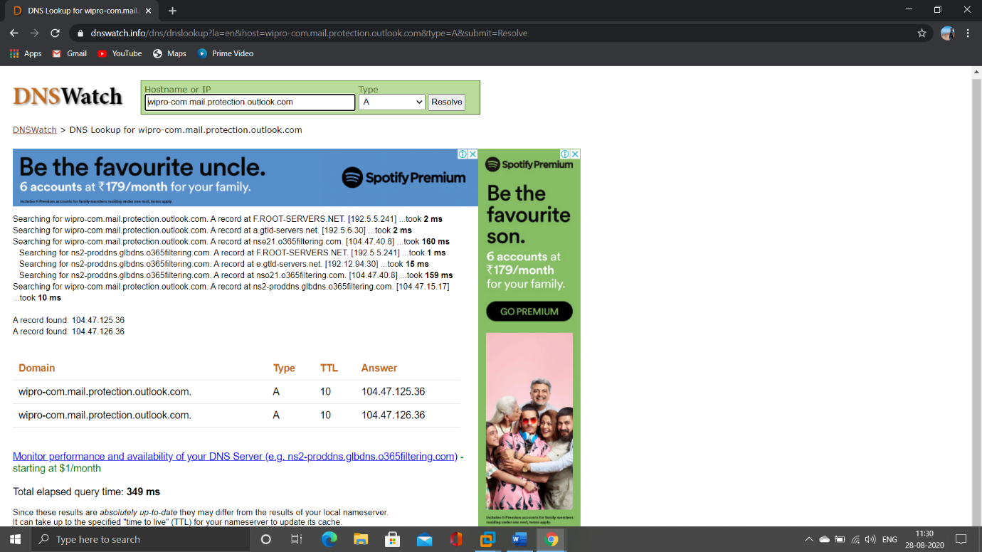

wipro-com.mail.protection.outlook.com has been assigned more than one IP’s

**I am using** [**https://www.ultratools.com/tools/geoIp**](https://www.ultratools.com/tools/geoIp) **to find the locations of IP’s of mail servers:**

**Location of IP’s**

1. **mx0b-001b2d01.pphosted.com**

148.163.158.5

This Mail server is Located at **Sunnyvale** city in United States

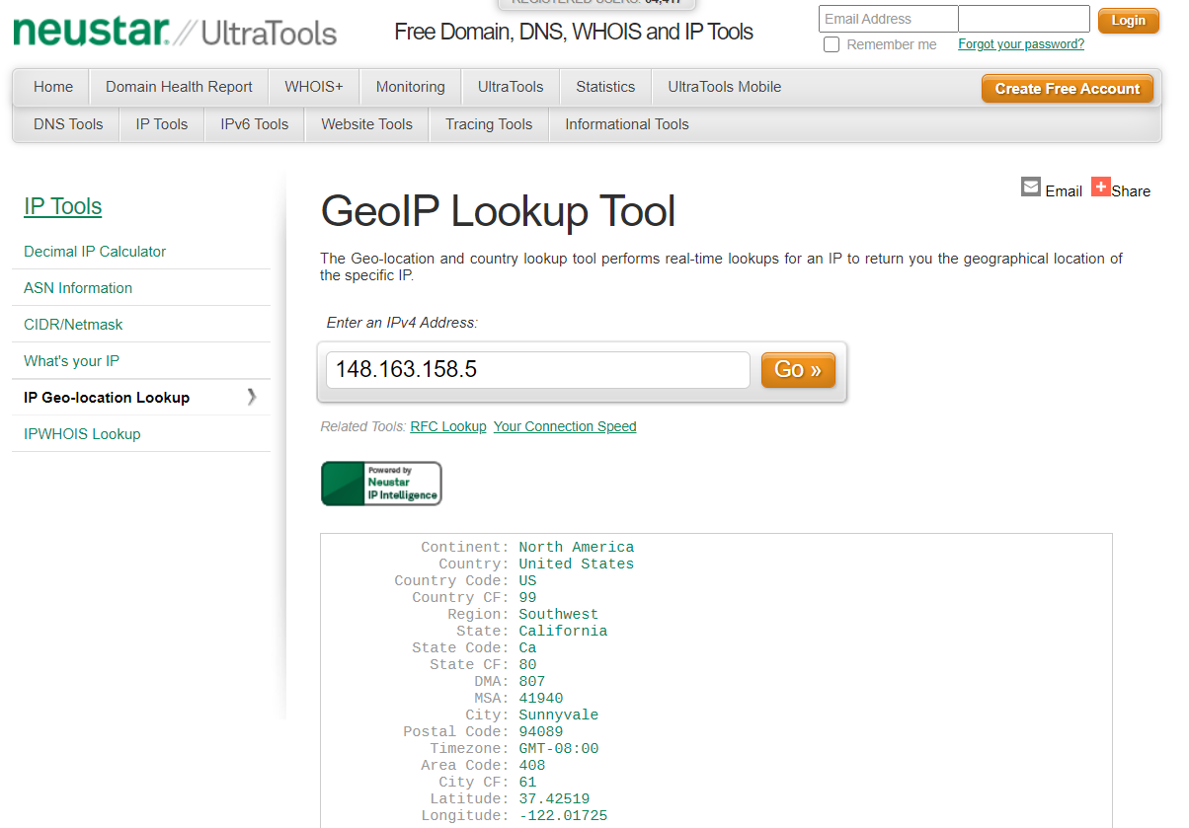

**2. mx0b-001b2d01.pphosted.com**

148.163.156.1

This Mail server is Locates at **Sunnyvale** city in United States

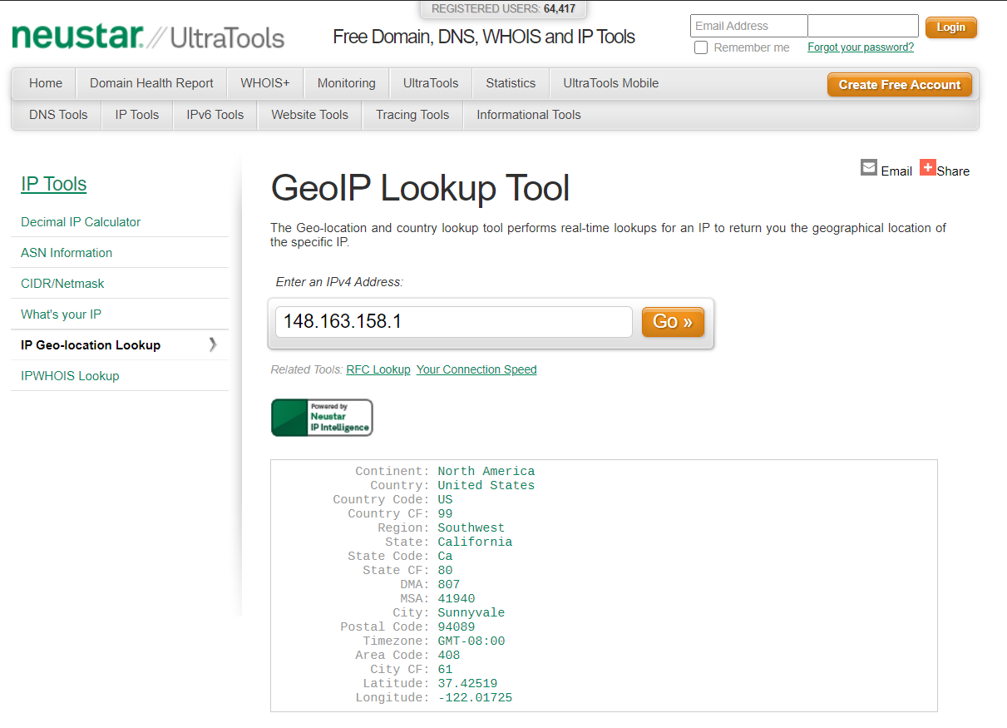

**3. wipro-com.mail.protection.outlook.com**

1. 104.47.125.36

This Mail server is Located at **Singapore.**

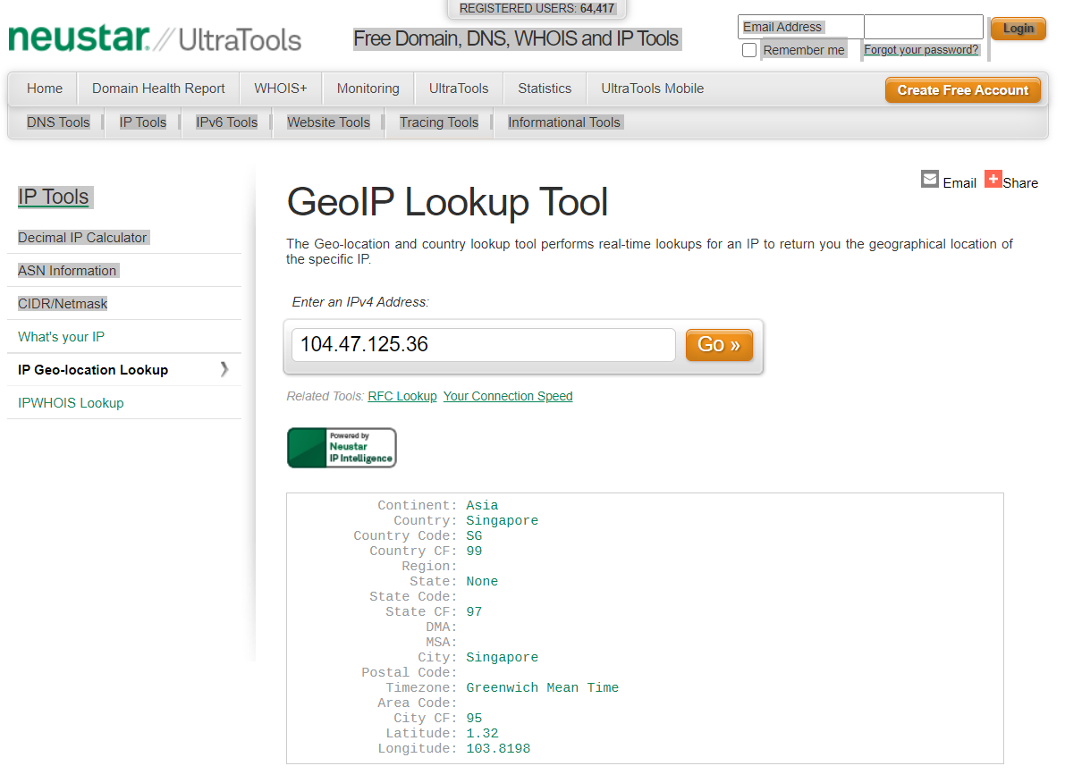

2. 104.47.126.36

This Mail Server is Located at **Busan** city in South Korea

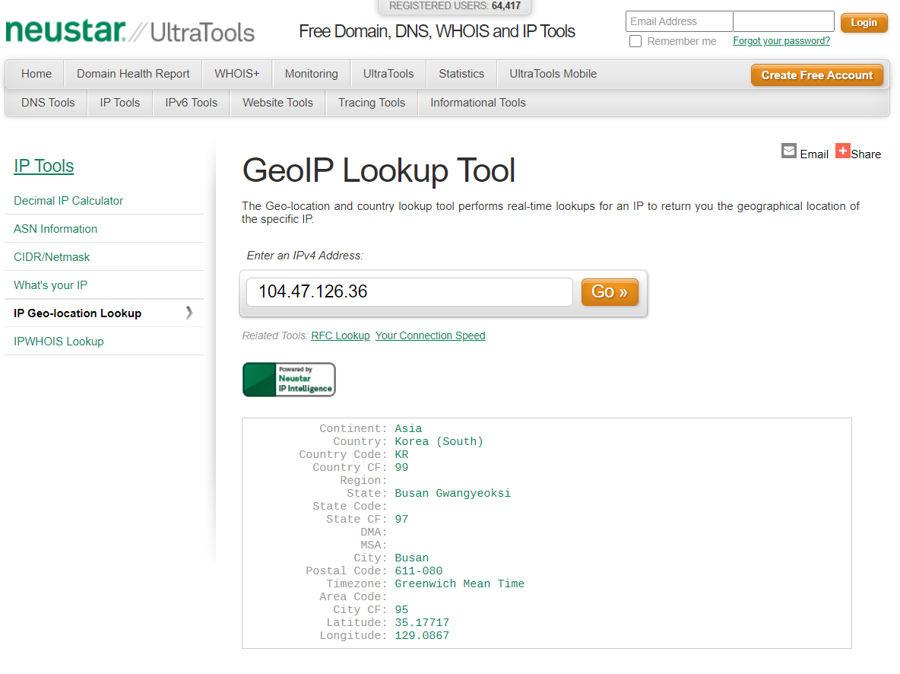

**Question 3:**

**Scan and find out port numbers open on 203.163.246.23**

**Answer:**

**Step 1** : Boot Up kali machine

**Step 2** : Open Terminal

**Step 3** : Give root Privilege By Typing **sudo su** and press enter then Type **Password** for the root Privilege and press enter

**Step 4** : Type the Command **nmap -p- 203.163.246.23**

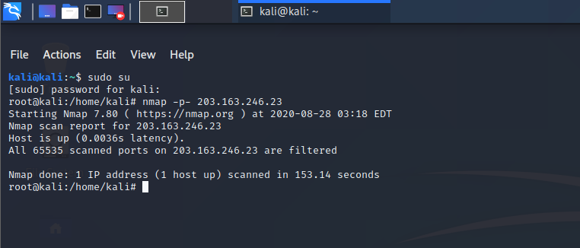

There are **0 open ports** in 203.163.246.23

**Question 4:**

**Install Nessus in a VM and Scan Your Laptop/desktop for CVE**

**Answer:**

1. Open Chrome and download nessus, click on localhost8834 and you get a link for where it will direct you to tenable community.
2. From where you can download nessus for free. (you need to have a professional Email ID)
3. Once nessus is opened put in your username and password.
4. Go to 🡪New scan, and then advanced scan.
5. Name: Domain controller not updated

Targets: write down the IP address

1. The go to credentials and then windows, type in the username and then type in the password, put in the domain
2. Once it is done click on 🡪Scan, then launch.
3. Once the scan is completed, click on it and you will be able to see the report (vulnarabilities)
4. Click on reports 🡪 HTML 🡪 custom 🡪 generate report. And you will get access to the CVE’s.

**Note** : as I don’t have business email I couldn’t complete the question 4, I will try to fix it out in the next assignment as of now I have typed the steps used to scan the os for CVE vulnerability